Amazon Sales Analytics: Data Analysis & Interactive Power BI Dashboard
Project Overview
This project is a detailed sales data analysis of an Amazon-style e-commerce dataset. The main goal is to understand sales performance, customer behaviour, product trends, and geographical distribution using data visualization tools like Power BI.
The project focuses on turning raw data into meaningful business insights that can help improve decision-making.

Dataset Description
The dataset contains 128,975 records of online orders with the following key fields:
- Order ID
- Date
- Status
- Fulfilment method
- Sales Channel
- Product details (Category, SKU, Style)
- Quantity sold (Qty)
- Sales Amount
- Shipping details
- Customer type (B2B / B2C)

Data Cleaning & Preparation
The following steps were performed before analysis:
- Converted Date column into proper datetime format
- Removed unnecessary column (Unnamed: 22)
- Handled missing values in Amount and other fields
- Ensured correct data types for numerical and categorical fields

Key Insights
- Identified top-performing product categories based on sales and quantity
- Analysed monthly sales trends to understand business growth patterns
- Found top states contributing to revenue
- Compared B2B and B2C customer segments
- Studied fulfilment methods and their distribution
- Identified best-selling SKUs/products

Dashboard Features (Power BI)
The interactive dashboard includes:
- KPI Cards (Total Sales, Total Orders, Total Quantity, Average Order Value)
- Monthly Sales Trend Analysis
- Category-wise Sales and Quantity Distribution
- Top Products and Customers
- State-wise Sales Performance Map
- B2B vs B2C Analysis
- Fulfilment Method Analysis
- Interactive Filters (Date, Category, State, Customer Type)

Tools & Technologies Used
- Power BI
- Python
- Python Libraries
- Microsoft Excel / CSV Dataset
- Data Cleaning & Preprocessing
- Data Visualization

Project Objective
To analyse e-commerce sales data and build an interactive dashboard that helps in understanding business performance, customer behaviour, and product demand patterns.

Outcome
This project helped in developing skills in:
- Data cleaning and preprocessing
- Business data analysis
- Dashboard design in Power BI
- Data storytelling using visuals

Dashboard Preview
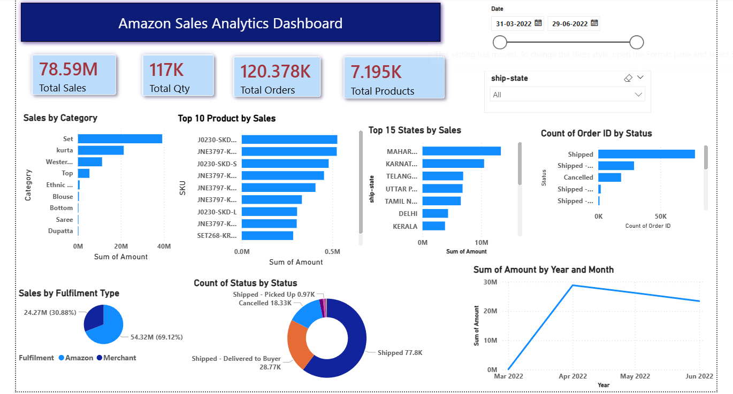

Author
- Name: D. Jaasritha
- Role: Data Analyst / ML Enthusiast
- Skills: Python, SQL, Power BI, Data Analysis

